The Archway Surgery, Armagh
Set-up assistance for online access to appointments and repeat prescriptions
Before you start, you will need a registration email or letter. You can get this by attending the surgery with identification. It looks like this (this one is an example – yours will have unique codes in the boxes):
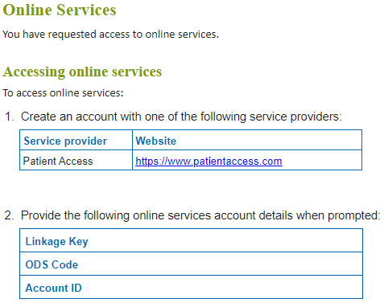
When you have received it, follow the steps below to set up your Patient Access account. If you expected to get it by email but can’t find it, check your junk mail folder!
Creating your Patient Access account
- Go to www.patientaccess.com and click Register.
- You will see the screen below. Enter your personal details. When finished, click continue.
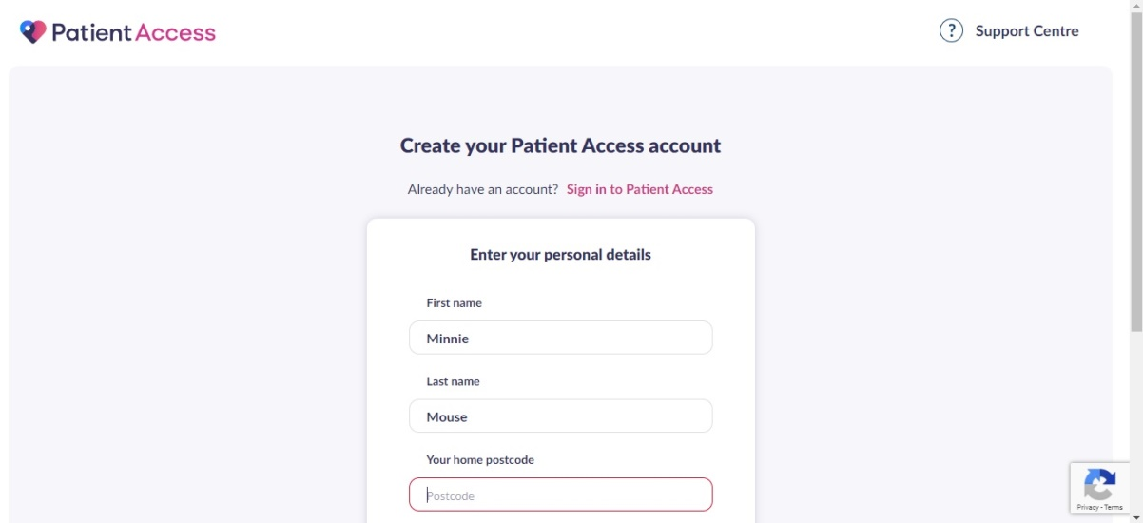
- The next screen looks like this:
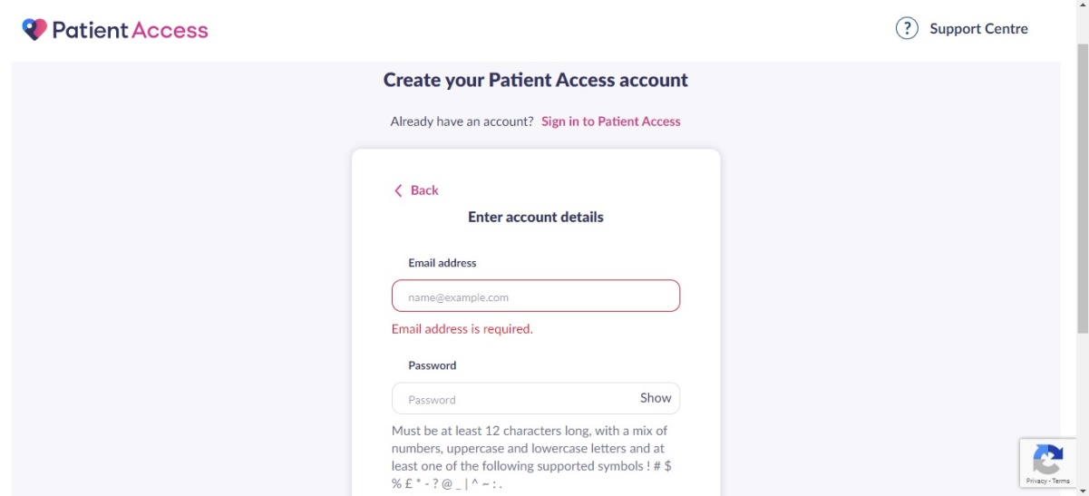
Enter your email address (this should match with the email address on your medical record, if you have supplied it to the practice) and create a password.
- Click to accept the Terms and Conditions.
- Select Create account.
That’s the first part done.

- You’ll then see the following screen:
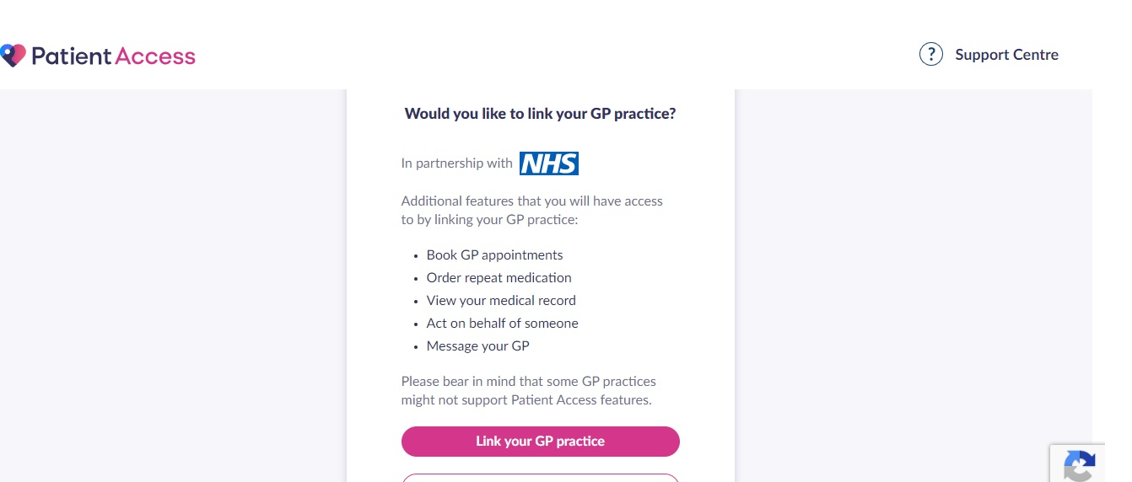
Click Link Your GP Practice.
- You’ll see the following: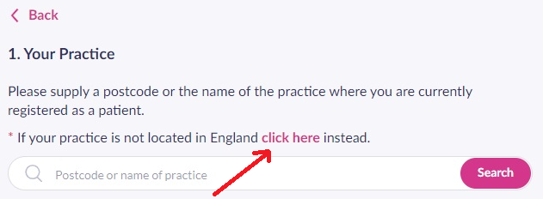
Click as indicated by the arrow.
- This will bring up the following: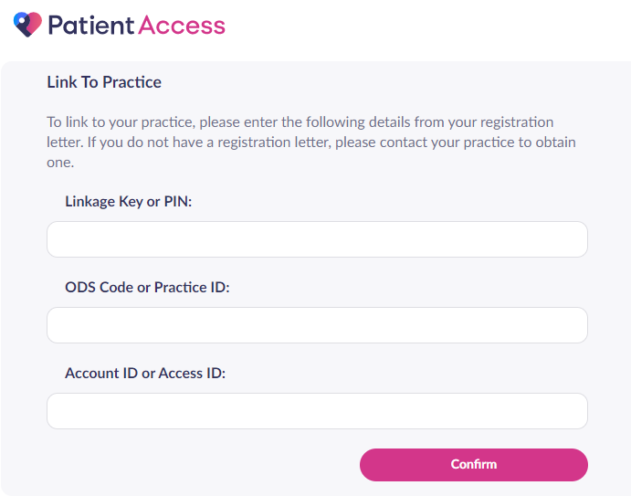
Enter the codes from the email or letter you received (as on page 1 of this document) and click confirm.
- You will be asked to confirm your personal details and password. The personal details must match those held by the practice. Then click Link account.

- On the confirmation screen, click Done.
Your account has now been linked to the practice! If you’d like some information on how to use Patient Access, click the Support Centre link on the website. Scroll down through this page to see all the help categories and video tutorials.
Adapted from patientaccess.com April 2020. Updated June 2020

